Departmental Library of the Department of Political Science, D.R.College
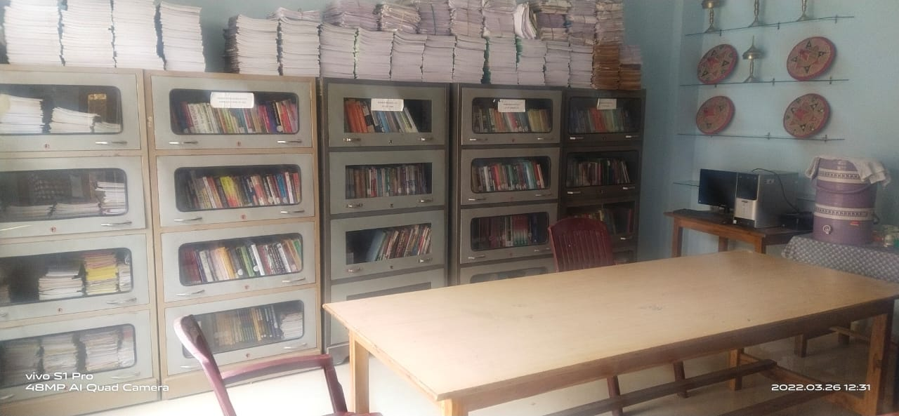
Computer Facility of the Department of Political science
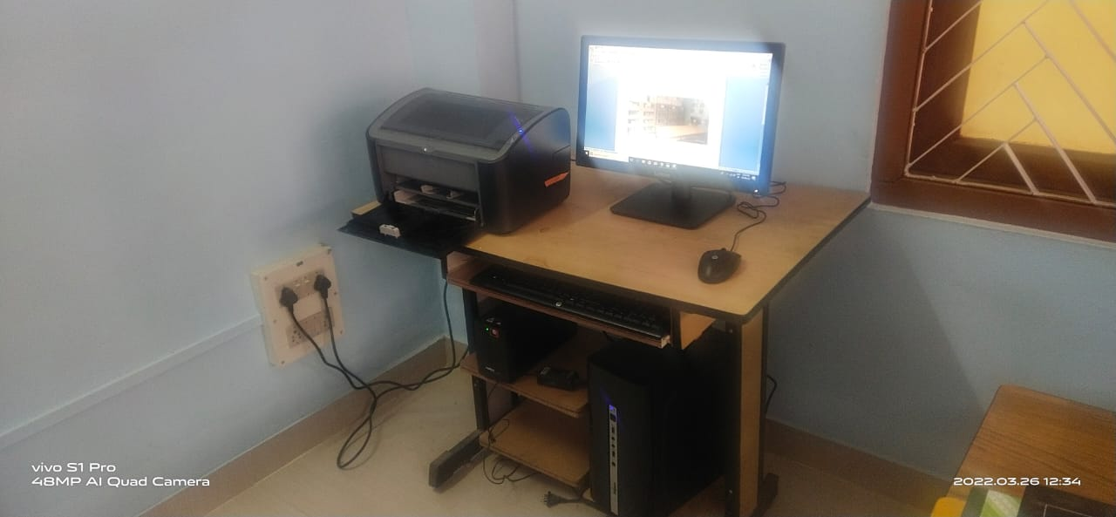

Books of the Departmental Library of Political Science
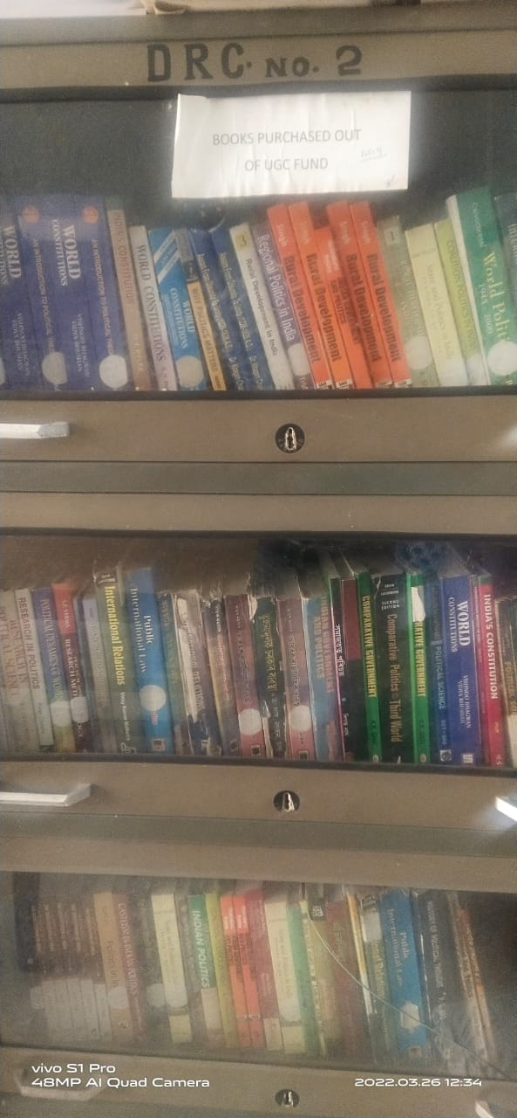

Wall Magazine of the Department of Political Science
